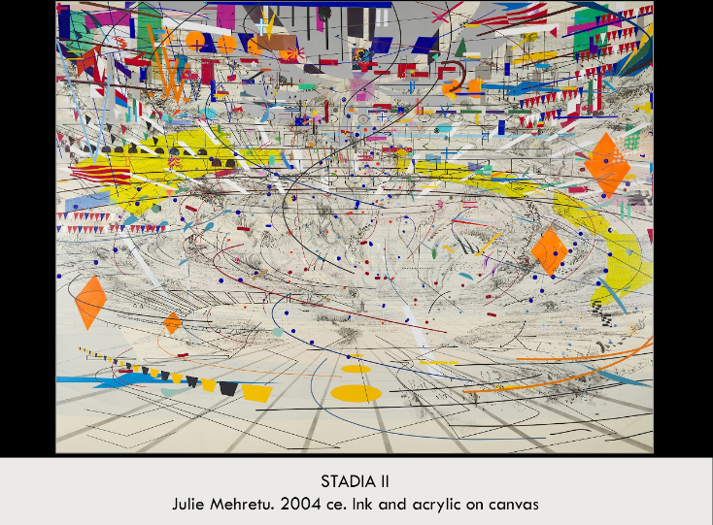

| **Form:** Ink and acrylic on Canvas, 108 x 144 inches and located in the Carnegie Museum of Art, Pittsburgh.  **Function:** To demonstrate and represent peoples collective experiences in such places, Gives a place where people can release energy in protest, pray, riot or anything else. Provoke thought abut our modern civilization  **Content:**  The base of the works black lines show a centrifugal structure that is reminiscent of a sports arena, an amphitheater or opera house. the composition or the painting mirrors the way crowds behave and exist within an environment such as a sports stadium or large competition with its uses bright and expressive color, geometric shapes, that are representative of banners, flags in the top. There are various shards of color floating throughout the piece. The overall scene is abstract but represents a sports arena, Small circles, dots, and hash marks float through the open space at the center of the composition, resembling the eruption of confetti that announces a winning team’s victory (or, alternately, that of a lucky political candidate on Election Day). larger circles, triangles, blocks and parallelograms that float across the upper register, these basic pictorial elements could comprise the designs of nearly any country’s national flag (cluster of red and blue stripes, for instance, located along the top-right edge of the canvas= American flag) but don't create an exact match. There are also shapes reminiscent of corporate logos and religious symbols interspersed throughout. The painterly gray marks that seem to rise from the lower and central registers like plumes of smoke could be representing that sadiums and capital buildings are also common targets for bombings and acts of terror, motivated by a comparable degree of zealousness and ideological fervor. The colors and shapes of the work seem to be suspended between surfaces and seem to swirl around an axis  **Context:** Staida II is part of a triptych of works, created in 2004, that explore the themes of nationalism and revolution in relation to how they occur in art, sports and contemporary politics. She created this work with by overlaying architectural plans, diagrams, and maps of the urban environment with abstract forms and personal notations. Resulting in a composition that convey the energy and chaos of today’s globalized world. Mehretu is intentionally drawing analogies between these forms and the propagandistic ways in which they are often used. She emphasizes the militarization of bodies moving within and between national (or digital) spaces, acknowledging the increasing speeds at which the world seems to be moving. While also showing the potential and importance of such interconnectedness.  **Compare:** Coliseum; Basquiat, Horn Players; Improvisation 28( second version) by Kandinsky; Composition of Red, Blue & Yellow by piet Mondrian  **246**  Global Contemporary |
| --- |

<https://docs.google.com/presentation/d/1JtXXhgfnaW-xOyysjtWeapbY7oIkb4a1BkeVKVD1WTY/edit?usp=sharing>